Foulsham Primary School’s Curriculum
The curriculum at Foulsham primary School has been carefully planned with input from many stakeholders in the school community, by working collaboratively with other small primary schools in the area and under the guidance of a National Leader of Education.
The curriculum has been carefully designed with the needs of our pupils in mind. These needs include:
- The need to develop learners who are excited about learning and display strong learning behaviours for this stage of education, as they move on to the next stage of education and for the rest of their lives.
- Whilst valuing the rural village community, broadening each child’s understanding of the wider world.
- To be ready for the next stage of education by being strong readers, writers, good with number, confident to use technology and able to apply these to a range of contexts.
- Developing children who are ready to be positive contributors as citizens of their local communities, broader communities and the world.

Curriculum Intents at Foulsham primary School
Overarching our curriculum are five intents. These intents drive our teaching and learning . Each half term we have an entire school theme for our learning which we call a ‘vehicle;’ this vehicle is used as a tool as we aim for our five intents.
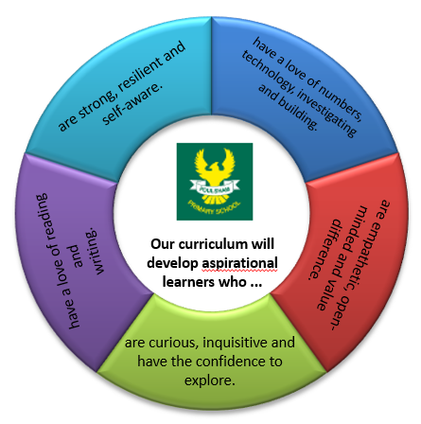

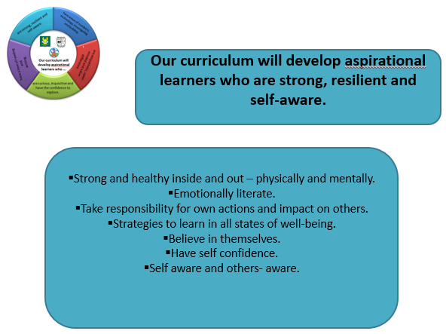
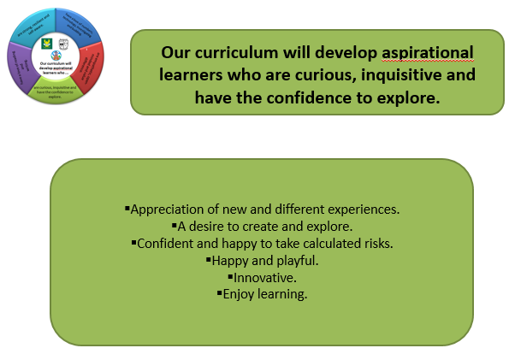
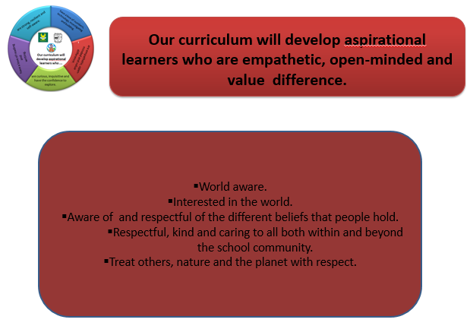
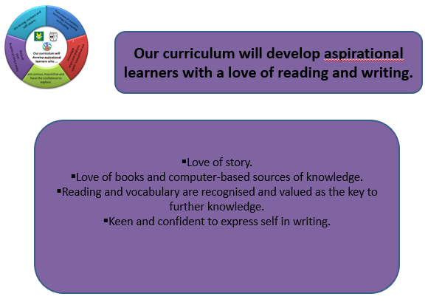
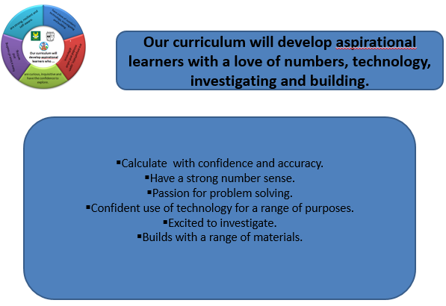
The National Curriculum
Although our curriculum is driven primarily by our five intents, the National Curriculum and Early Learning Goals form the backbone of our curriculum. Coverage of this is carefully planned to ensure knowledge and skills are built effectively over the course of the primary years.

The Foulsham Passport
Running very closely alongside our main curriculum is the ‘Foulsham Passport.’ This part of our curriculum sets out some key experiences we aim for our children to have in their time with us to enrich the range of life experiences which they may have. The range of experiences is diverse from enjoying a sleepover to visiting Parliament. The purpose of the ‘Foulsham Passport’ is to provide a broad range of experiences which children can draw on when learning in the classroom, to make links and to feed into our five intents.
